11. Print all factors of a number
#include <iostream>
using namespace std;
int main()
{
int n;
cout << "Enter a number: ";
cin >> n;
cout << "Factors of " << n << " are: ";
for (int i = 1; i <= n; i++)
{
if (n % i == 0)
{
cout << i << " ";
}
}
return 0;
}
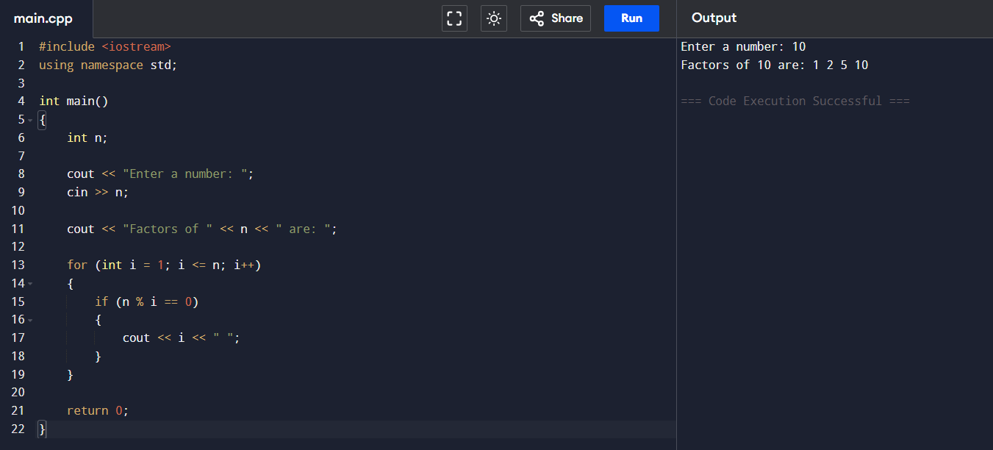

12. Pyramid pattern
#include <iostream>
using namespace std;
int main()
{
int n;
cout << "Enter the number of rows: ";
cin >> n;
for (int i = 1; i <= n; i++)
{
for (int j = 1; j <= n - i; j++)
cout << " ";
for (int k = 1; k <= i; k++)
cout << k << " ";
cout << endl;
}
return 0;
}
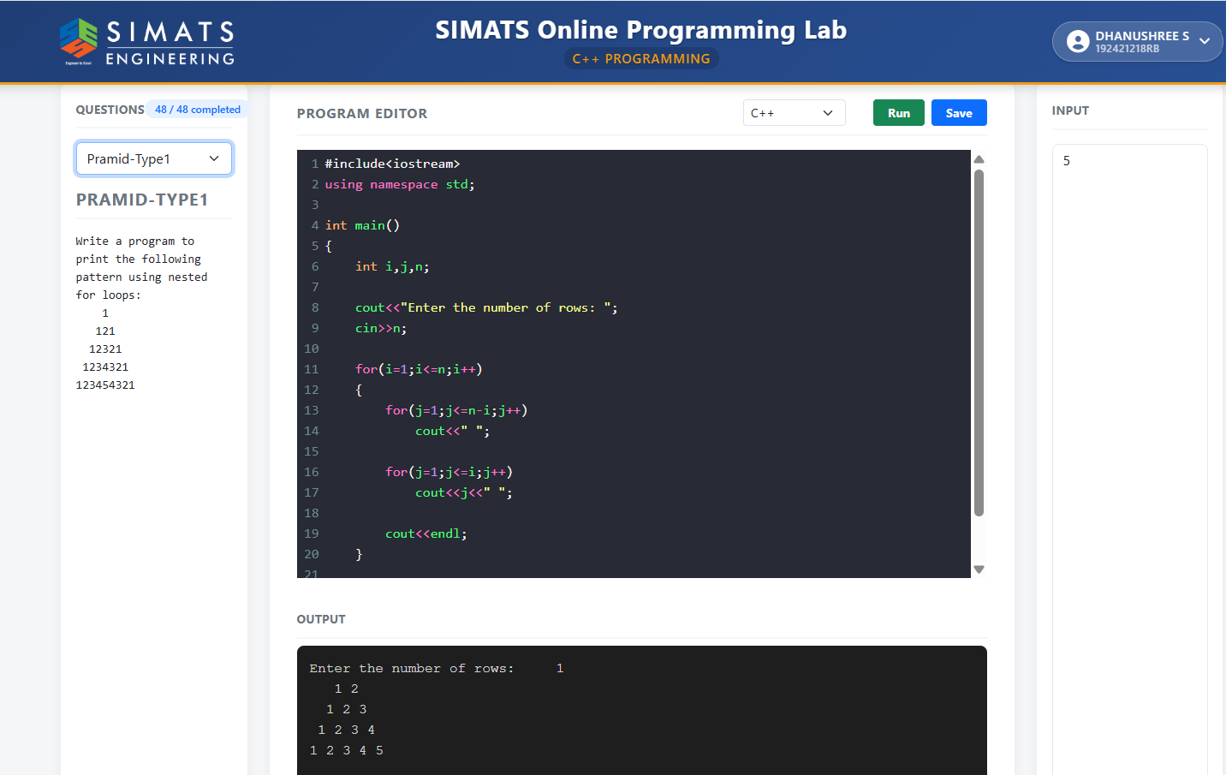
13.Find the power of a number
#include <iostream>
using namespace std;
int main()
{
int base, exponent, power = 1;
cout << "Enter base: ";
cin >> base;
cout << "Enter exponent: ";
cin >> exponent;
for (int i = 1; i <= exponent; i++)
{
power = power * base;
}
cout << "Power = " << power;
return 0;
}
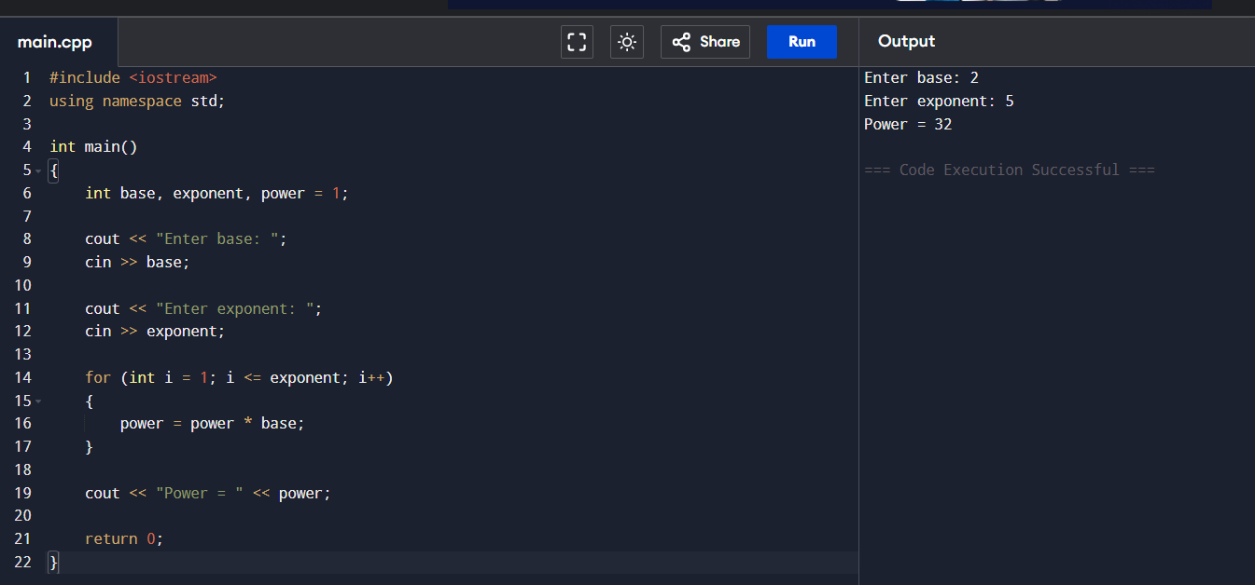

14.Inverted pyramid pattern.
#include <iostream>
using namespace std;
int main()
{
int n;
cout << "Enter the number of rows: ";
cin >> n;
for (int i = n; i >= 1; i--)
{
for (int j = 1; j <= n - i; j++)
cout << " ";
for (int k = 1; k <= (2 * i - 1); k++)
cout << "*";
cout << endl;
}
return 0;
}
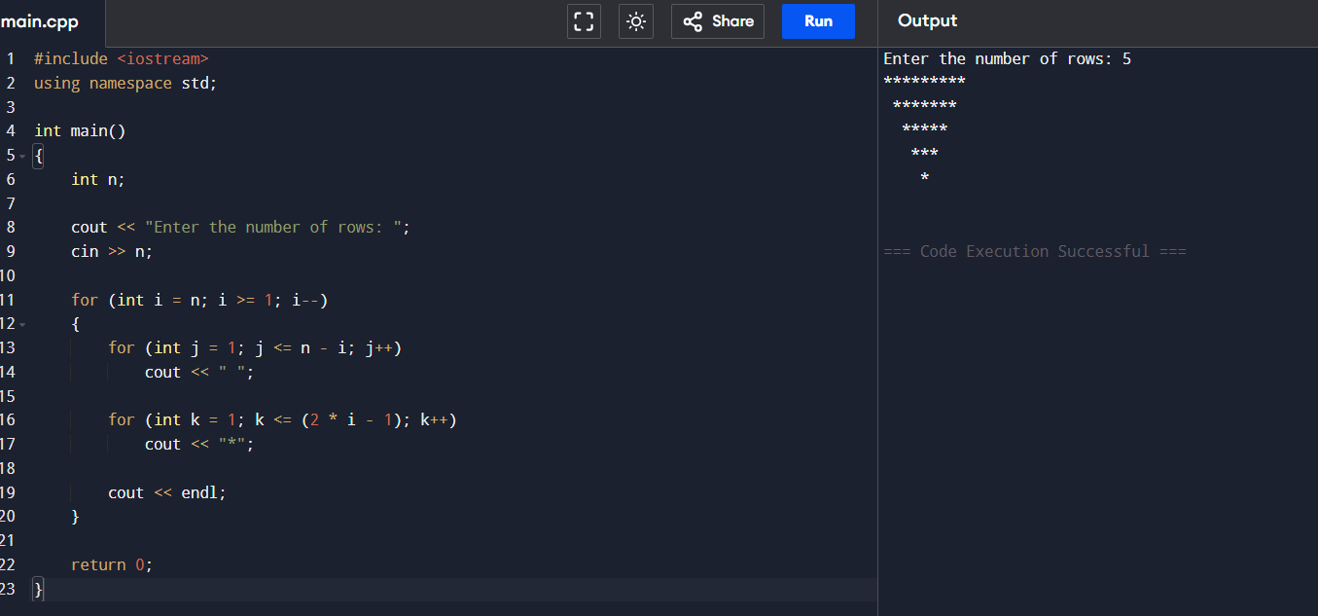

15. Find the sum of positive and negative numbers from a list.
#include <iostream>
using namespace std;
int main()
{
int n,num,positiveSum=0,negativeSum=0;
cout<<"Enter the number of elements: ";
cin>>n;
for(int i=1;i<=n;i++)
{
cin>>num;
if(num>0)
positiveSum+=num;
else if(num<0)
negativeSum+=num;
}
cout<<"Sum of Positive Numbers = "<<positiveSum<<endl;
cout<<"Sum of Negative Numbers = "<<negativeSum;
return 0;
}
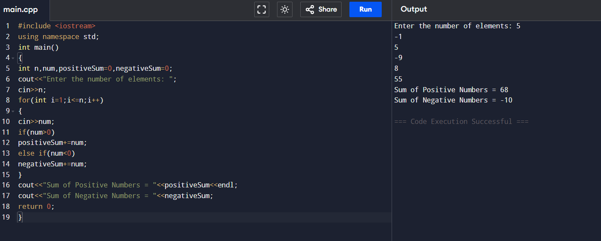

16. Print all prime numbers between two given numbers.
#include <iostream>
using namespace std;
int main()
{
int a,b,i,j,isPrime;
cout<<"Enter two numbers: ";
cin>>a>>b;
for(i=a;i<=b;i++)
{
if(i<2)
continue;
isPrime=1;
for(j=2;j<=i/2;j++)
{
if(i%j==0)
{
isPrime=0;
break;
}
}
if(isPrime)
cout<<i<<" ";
}
return 0;
}

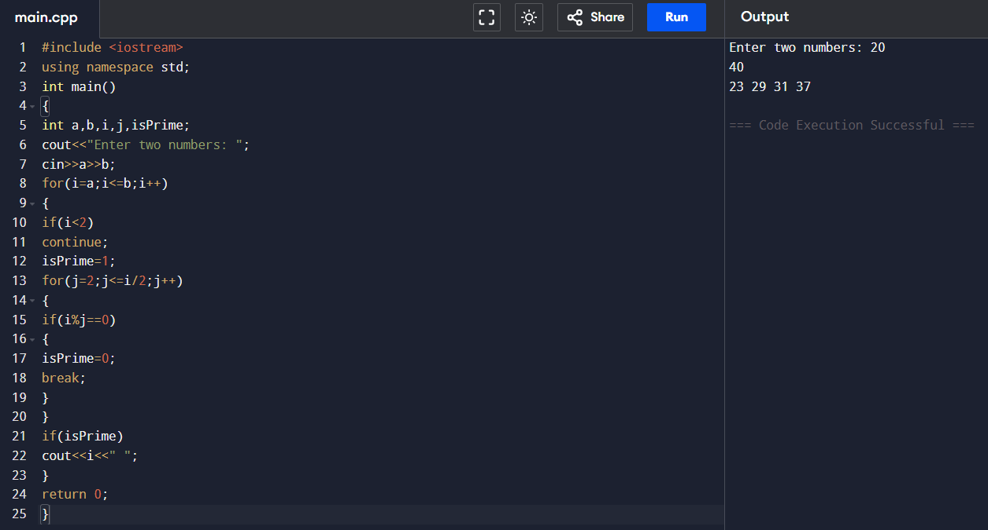
17. Generate a multiplication table
#include <iostream>
using namespace std;
int main()
{
int n,i;
cout<<"Enter a number: ";
cin>>n;
for(i=1;i<=10;i++)
{
cout<<n<<" x "<<i<<" = "<<n*i<<endl;
}
return 0;
}
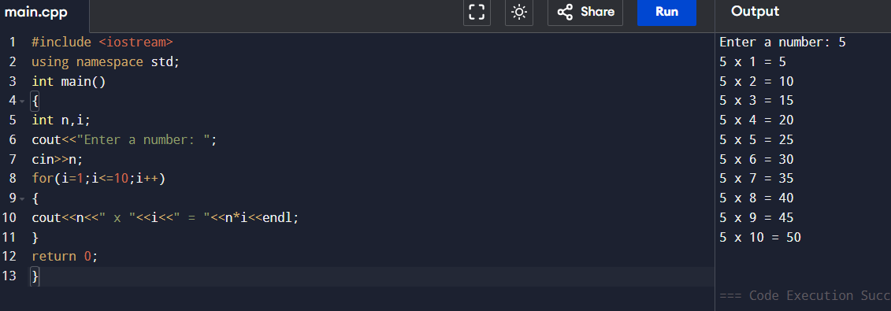
18.Check whether a number is an automorphic number.
#include <iostream>
using namespace std;
int main()
{
int n,temp,square,digits=0,power=1;
cout<<"Enter a number: ";
cin>>n;
temp=n;
square=n*n;
while(temp>0)
{
digits++;
temp=temp/10;
}
for(int i=1;i<=digits;i++)
power=power*10;
if(square%power==n)
cout<<"Automorphic Number";
else
cout<<"Not an Automorphic Number";
return 0;
}
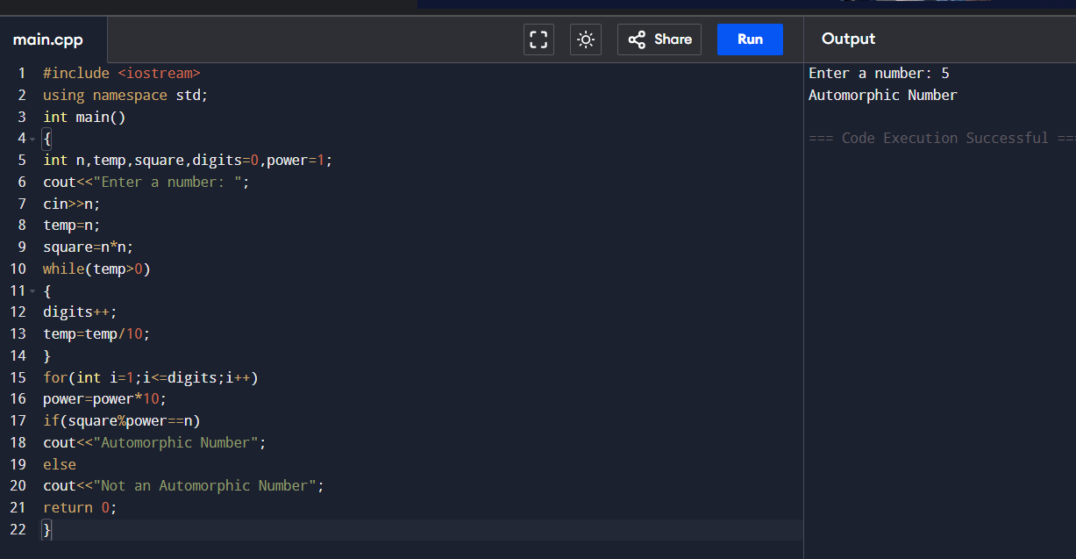

19.Diamond pattern.
#include <iostream>
using namespace std;
int main()
{
int n,i,j,k;
cout<<"Enter the number of rows: ";
cin>>n;
for(i=1;i<=n;i++)
{
for(j=1;j<=n-i;j++)
cout<<" ";
for(k=1;k<=2*i-1;k++)
cout<<"*";
cout<<endl;
}
for(i=n-1;i>=1;i--)
{
for(j=1;j<=n-i;j++)
cout<<" ";
for(k=1;k<=2*i-1;k++)
cout<<"*";
cout<<endl;
}
return 0;
}
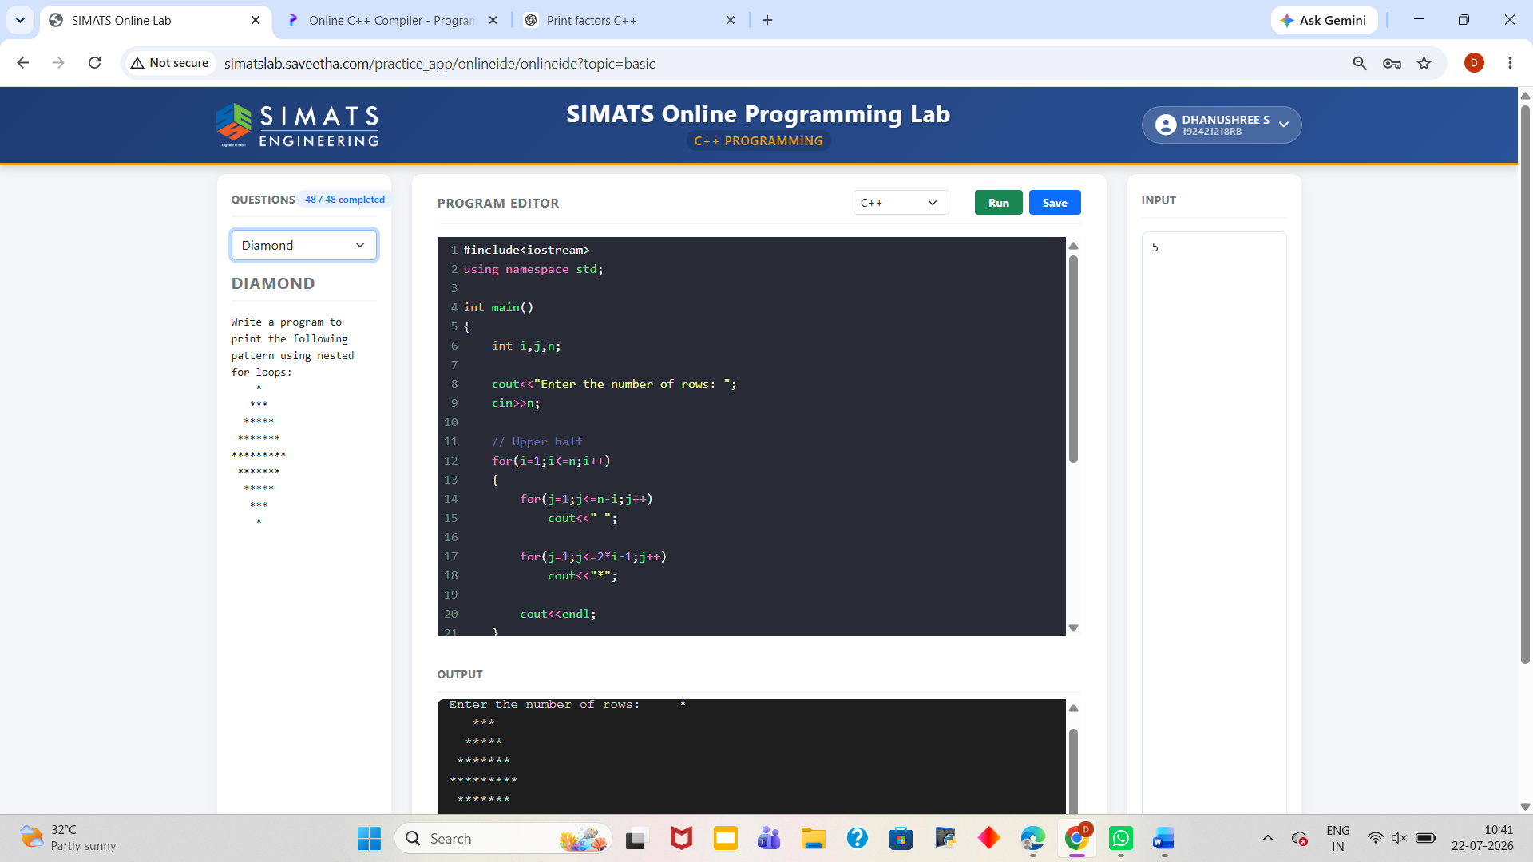

20.Convert hexadecimal to decimal and decimal to hexadecimal
#include <iostream>
using namespace std;
int main()
{
int choice,d;
string h;
cout<<"1.Decimal to Hexadecimal\n2.Hexadecimal to Decimal\n";
cout<<"Enter your choice: ";
cin>>choice;
if(choice==1)
{
cout<<"Enter decimal number: ";
cin>>d;
cout<<"Hexadecimal = "<<hex<<d;
}
else if(choice==2)
{
cout<<"Enter hexadecimal number: ";
cin>>h;
cout<<"Decimal = "<<stoi(h,nullptr,16);
}
else
{
cout<<"Invalid Choice";
}
return 0;
}
